**Online Vehicle Registration and Driver’s License System Application**

**(Central Processing System)**

*QA Test Plan*

*Version: <1.0>*

*Prepared By: Group 8*

*Date: 04/25/2023*

**Table of Contents**

1 Document Acceptance and Sign-Off 3

2 Revision History 4

3 Glossary 5

1. Test Product Overview 5

2. Test Planning 5

3.2.1 Purpose 5

3.2.2 Objectives 5

3.2.3 In Scope & Out of Scope 5

3. Test Definitions and Phases 6

4. Test Environments 6

5. Test Data 6

6. Test Tools 6

7. Testing Team Roles and Responsibilities 6

8. Entrance and Exit Criteria 6

9. Assumptions, Constraints, Dependencies, Risks, and Limitations 6

10. Risks & Assumptions 6

11. Defect Management Process 7

12. Test Schedule 7

13. References 7

14. Standards, Plans, and Procedures 7

# Document Acceptance and Sign-Off

By signing below, I acknowledge that I have read the entire contents of this document and accept the document in this form as reasonably fulfilling the goals described in the section titled Document Purpose. I further agree that this will constitute the document of record and cannot be changed without review and acknowledgement of the groups shown below:

|  |  |  |  |
| --- | --- | --- | --- |
| **Group / Role** | **Approver Name** | **Approver Signature** | **Date Approved** |
| Group 8/ QA | Mansi Zope | MZ | 04/26/2023 |
| Group 8/ QA | Ruchita Yarlagadda | RY | 04/26/2023 |
| Group 8/ QA | Mengxia Zhang | MEZH | 04/26/2023 |
| Group 8/ QA | Hemanth Reddy Yaramala | HRY | 04/26/2023 |

# Revision History

|  |  |  |  |
| --- | --- | --- | --- |
| Document/Department Editor: | | | |
| **Date** | **Revision #** | **Editor** | **Description of Change** |
| 04/17/2023 | Rev0 | Group 8 | Initial Project Discussion, splitting work between the team |
| 04/18/2023 | Rev1 | Mansi | Test Condition Matrix, Test Scenarios and Test Cases and Traceability Matrix for Registration |
| 04/18/2023 | Rev2 | Mengxia | Test Condition Matrix, Test Scenarios and Test Cases and Traceability Matrix for Car Dealership |
| 04/19/2023 | Rev3 | Ruchita | Test Condition Matrix, Test Scenarios and Test Cases and Traceability Matrix for Fleets |
| 04/19/2023 | Rev4 | Hemanth | Test Condition Matrix, Test Scenarios and Test Cases and Traceability Matrix for Trucking Union |
| 04/20/2023 | Rev5 | Mansi | Test Condition Matrix, Test Scenarios and Test Cases and Traceability Matrix for Individual Drivers |
| 04/20/2023 | Rev6 | Ruchita | Test Condition Matrix, Test Scenarios and Test Cases and Traceability Matrix for Financial Reconciliation |
| 04/21/2023 | Rev7 | Mansi | Test Product Overview, Test Planning, Test Definitions and Phases |
| 04/22/2023 | Rev8 | Ruchita | Test Environment, Test Data, Test Tools |
| 04/22/2023 | Rev9 | Hemanth | Test team roles and responsibilities, entry and exit criteria, assumptions, and dependency |
| 04/24/2023 | Rev10 | Mengxia | Risks, Defect Management Process, Test Schedule |

# Glossary

|  |  |
| --- | --- |
| **Term** | **Definition** |
| Application | A computer software program that performs a special task |
| Claim | A request to your insurance company to pay a bill for service |
| Car Dealership | A car dealership is a business that sells new or used cars, offers financing and insurance options, and provides maintenance and repair services. |
| Fleets | A fleet is a group of vehicles owned or leased by a company or organization, typically used for business purposes such as transportation, delivery, or service. |
| Trucking Union | A trucking union is an organization that represents and advocates for the rights and interests of truck drivers and other workers in the trucking industry, often negotiating collective bargaining agreements on their behalf with employers. |
| Financial reconciliation | Financial reconciliation is the process of comparing financial transactions and records to ensure their accuracy and consistency, typically involving identifying and resolving any discrepancies or errors. |

## Test Product Overview

The purpose of the Online Vehicle Registration and Driver's License Application (Central Processing System) is to simplify the process of registering vehicles and obtaining driver's licenses through a web-based platform. This system enables various known entities, such as dealerships, fleets, trucking unions, and individual drivers to register with service providers and submit their applications electronically. Once the applications are submitted, the system processes them and delivers the registrations or driver's licenses to the entities or individual drivers. The application aims to offer a hassle-free and user-friendly experience while ensuring adherence to relevant regulations, standards, and laws. Additionally, the system performs weekly financial reconciliations between the Central Processing System (CPS) or CPS_Lite and ACH to guarantee the accuracy of transactions.

**Major new or modified capabilities included in this test**

1. **Entity Registration**
   1. Entities like car dealerships, fleets, and trucking union can register their vehicles with the service provider
   2. Individual drivers do not need service providers and they can register directly with the insurance companies
   3. To register with the service provider the bond value should be greater than $1M, insurance ranking score should be greater than 8, entity should have an appropriate financial and state approval, along with an insurance coverage. If all these conditions are met, then the Registration_flag is set to True.
   4. To register with the insurance company individual driver should have insurance ranking score greater than 8 and an appropriate financial and state approval. If all these conditions are met, then the Registration_flag is set to True.
   5. All these details are sent to CPS or CPS_Lite when the registration flag is set to true.
2. **Transaction Processing for Car Dealerships and Fleets**
   1. Once the Car dealerships and fleets are registered, they can send the new/renewal transaction to CPS
   2. Car dealerships and fleets can only have CVR, Dealer Services and Boston Marathon Software as their Service Providers.
   3. Service providers request the insurance approval from the insurance company. Acceptable insurance companies are – Liberty Mutual, Geico, Progressive only.
   4. After getting insurance approval, service providers send the fees information to ACH. Acceptable ACH are – Captial one and Chase bank only.
   5. Once the transaction is successful, it sends the approved transaction to the CPS. CPS processes the transaction and sends the registration to the entities.
3. **Transaction Processing for Trucking Union**
   1. Once the Trucking Unions are registered, they can send the new/renewal transaction to CPS
   2. Trucking Union can only have Boston Marathon Software as their Service Provider.
   3. Service providers request the insurance approval from the insurance company. Acceptable insurance companies are – Liberty Mutual and Progressive only.
   4. After getting insurance approval, service providers send the fees information to ACH. Acceptable ACH are – BOFA only.
   5. Once the transaction is successful, it sends the approved transaction to trucking approval and if it is approved then it is sent to the CPS otherwise rejected. CPS processes the transaction and sends the registration to the entities.
4. **Transaction Processing for Individual Drivers**
   1. Once the Individual drivers are registered, they can send the new/renewal transaction to CPS_Lite
   2. Insurance company send the fees information to ACH. Acceptable ACH are – Credit Card and PayPal only. Acceptable insurance companies are – Liberty Mutual and Progressive only.
   3. Once the transaction is successful, it sends the approved transaction to trucking approval and if it is approved then it is sent to the CPS_Lite otherwise rejected. CPS _Lite processes the transaction and sends the registration to the entities.

**Context diagram of the product**

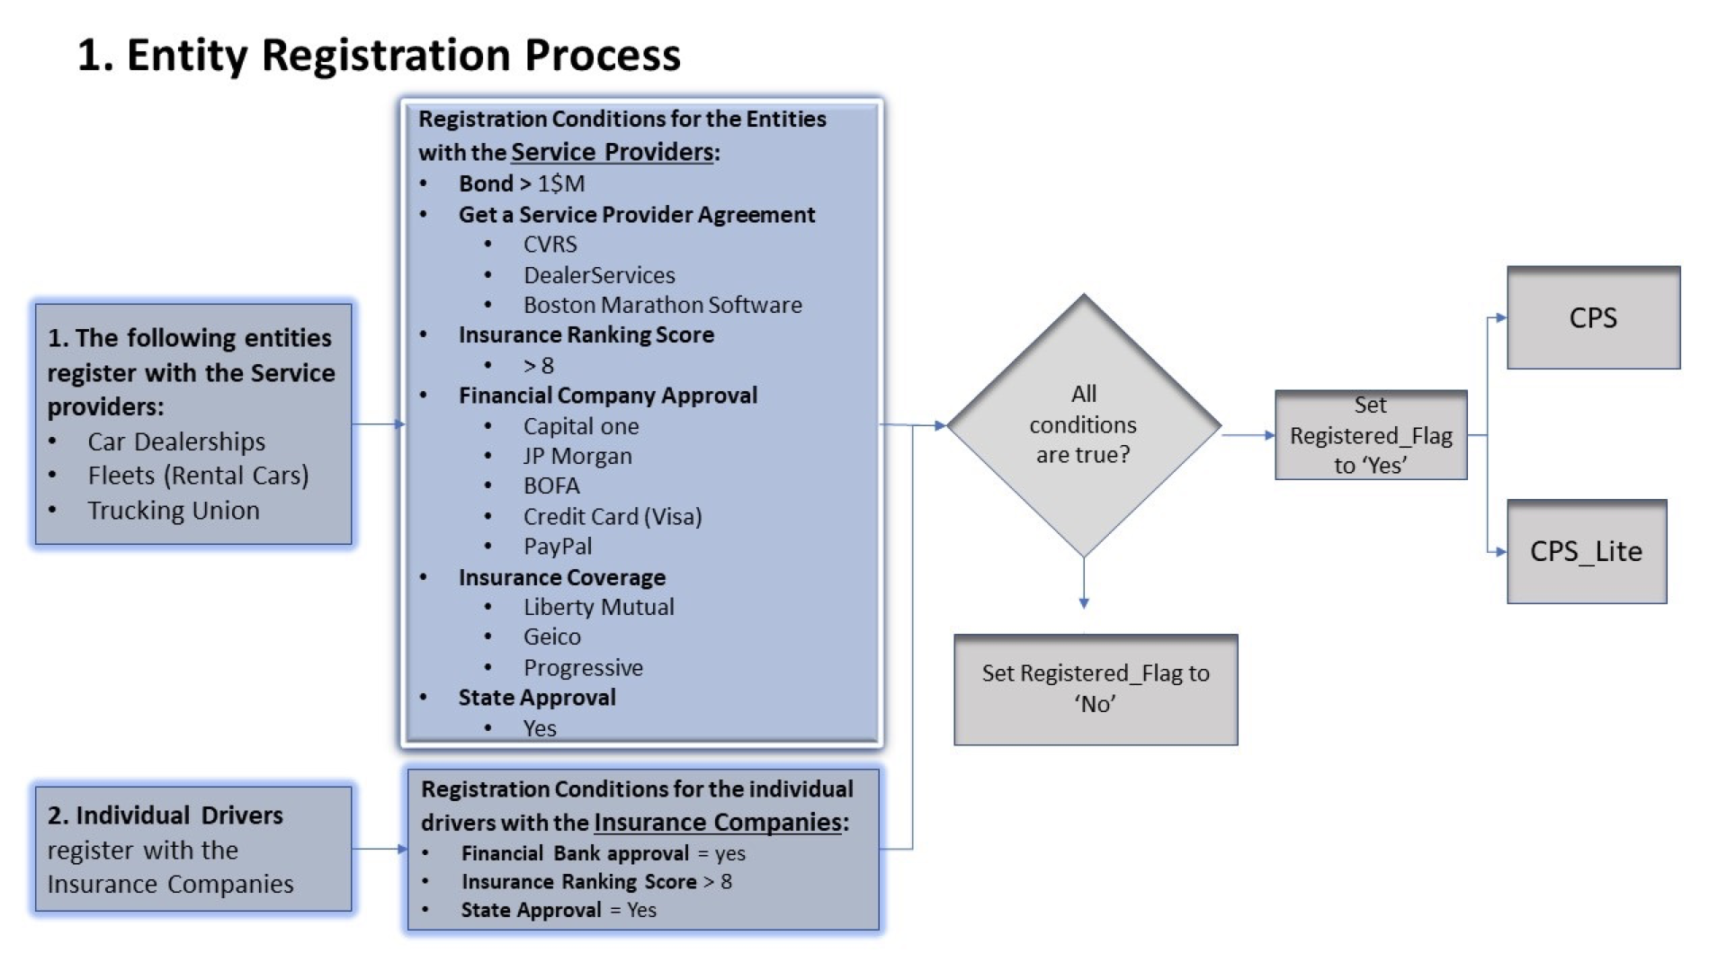

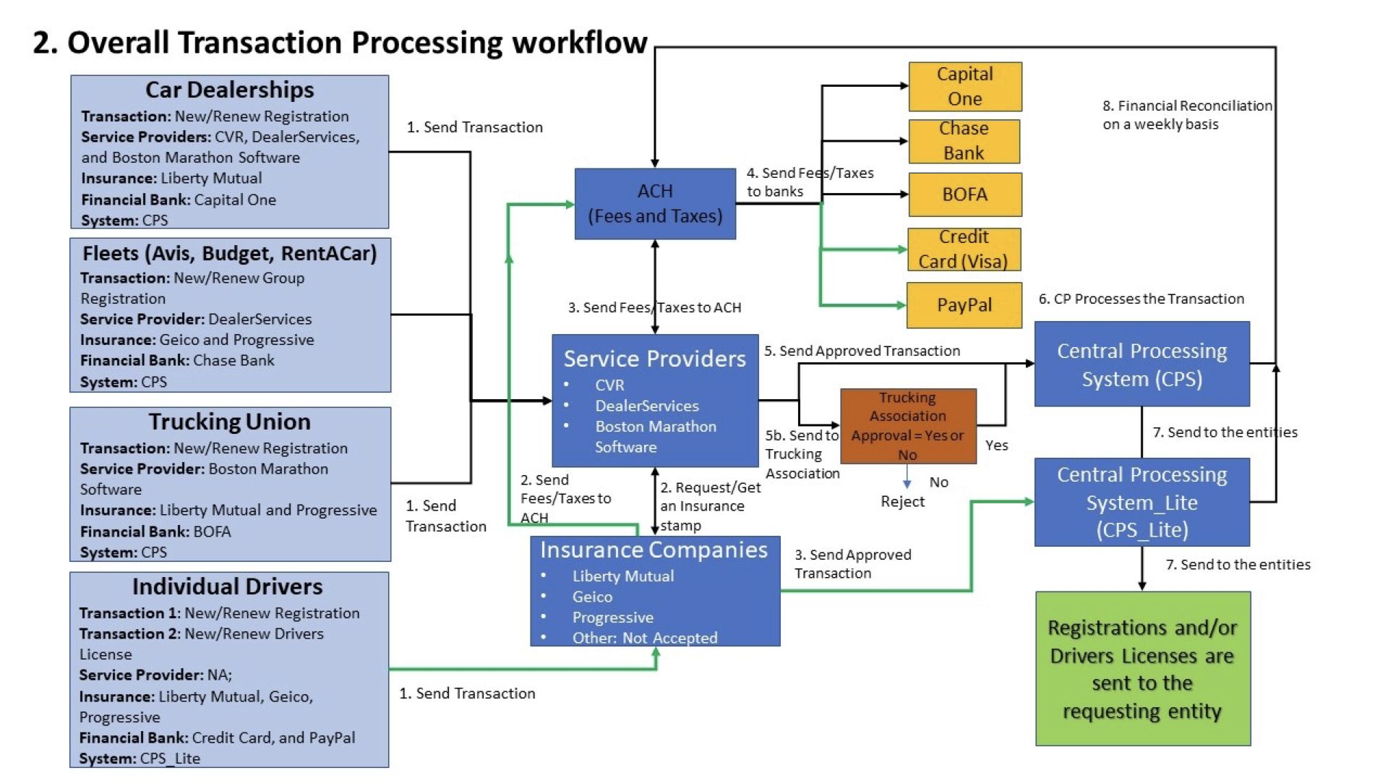

**Hardware (Physical/VM/Cloud):**

1. CPU: Intel i7
2. RAM: 16 GB
3. Storage: 1TB
4. Internet: LAN/Wi-Fi/VPN

**Software:**

1. OS: Windows 7,10,11, Mac OSX
2. Browsers: Google Chrome, Firefox, Safari, Edge
3. Security: Norton 360, McAfee Total Protection

## Test Planning

### Purpose

The purpose of this document is to provide a detailed summary of the testing procedure for online vehicle registration and driver's license system applications. This document is an outline for testing team that tells how to carry out testing activities in structured way. Test Planning document includes objectives, scope, testing approach, environment, test data, test tools, testing team roles and responsibilities etc.

### Objectives

The objective of testing the Online Vehicle Registration Application is to verify that it fulfils all functional and non-functional requirements, works dependably, and offers an effortless and user-friendly experience for various groups, such as vehicle owners, government agencies, and other stakeholders. The testing will scrutinize all aspects of the system, encompassing registration processing, user management, communication interfaces, and reporting functions. Its goal is to uncover any defects or problems that might affect the system's performance, security, usability, or functionality and ensure that they are fixed before deploying the system in a production environment. In addition, the testing will guarantee that the system adheres to all applicable standards, regulations, and laws and that it is available to users with disabilities.

### In Scope & Out of Scope

4.2.3.1 In Scope -

1. Registration for entities like Car Dealerships, Fleets, Trucking Union, and Individual Drivers.
2. Conditions for successful entity registration with Service Providers.
3. The capability for registered entities and individual drivers to transmit transactions to the CPS or CPS_Lite.
4. Delivery of registrations or driver's licenses to organizations or individual drivers after transaction processing by the system.

4.2.3.2 Out of Scope -

1. Training and testing for driver’s license.
2. Reminders or messages about vehicle registration renewal.
3. Changes to back-end systems or infrastructure.
4. Any changes in the Service Providers' registration criteria.
5. Any changes in the insurance company registration requirements for individual drivers.

## Test Definitions and Phases

**Unit Testing:** Unit Testing is performed to test the individual components or modules of the system to ensure that they work correctly.

**Integration Testing:** Integration Testing is performed to test how different components or modules of the system work together and verify that the interfaces between them function correctly.

**System Testing:** System Testing is performed to test the system to ensure that all its components work together as expected and meet the system's requirements.

**User Acceptance Testing:** User Acceptance Testing is performed to test the system with end-users to ensure that it meets their needs and is easy to use.

**Regression Testing:** Regression Testing is done to ensure that changes or fixes to the system have not introduced new defects or issues.

**Performance Testing:** Performance Testing is done on the system's performance under different loads and conditions to ensure that it meets performance requirements.

**Security Testing:** Security Testing is done to test the system's security to ensure that it is secure from external threats and meets security requirements.

**Accessibility Testing:** Accessibility Testing is done to test the system's accessibility to ensure that it is usable by people with disabilities.

## Test Environments

A testing environment is a setup that includes all the necessary software and hardware configurations needed for testing. The specific configuration of the testing environment will depend on the needs of the application being tested and the requirements of the build.

To create a test environment, several distinct areas must be set up, including:

**Configuration of a Test Server**: Depending on the nature of the test, it may be necessary to establish a separate test server rather than running the test on a local machine.

**Establishment of a Network**: Setting up an Internet connection, LAN, or Wi-Fi connection is necessary to enable communication between the test server and the test PC.

**Test PC Configuration**: Configuring the test PC with the necessary software and hardware components to conduct the test.

**Creation of Test Data**: Preparing test data that will be used within the test environment.

**Implementation of Bug Reporting Tools**: Installing tools that will allow for effective reporting and tracking of bugs that are identified during testing.

|  |  |
| --- | --- |
| Operating System | Windows, macOS |
| Web Browsers | Chrome, Safari, Microsoft Edge |
| Security | McAfee Total Protection, Norton 360 |
| Software | ALM, Selenium, LoadRunner, UFT, JMeter |

## Test Data

Test data, like the test environment, is reliant on the specific application being examined by the QA. The testing team can generate suitable test cases and data by analysing the application's requirements and considering the test scenarios that need to be evaluated.

Here are some ways to generate test data:

* Use data generators or tools to create test data automatically.
* Using the application requirements and test scenarios, manually produce test data.
* Create anonymised test data using techniques like data masking or obfuscation.

Necessary test data includes:

* URL of the application or the installation of the desktop application on the system if it is a desktop application.
* Data regarding the entities like dealerships, fleets, trucking union, and individual drivers.
* Registration data for dealerships, fleets, and trucking unions to register with service providers and for individual drivers to register with the insurance companies.

## Test Tools

Testing tools are created with the objective of automating the testing process and making it more efficient and effective. These tools enable testers to conduct tests with less time and effort, ensuring that the application complies with the requirements and performs as intended.

|  |  |
| --- | --- |
| **Testing** | **Tools** |
| Performance Testing | JMeter, LoadRunner |
| API Testing | Postman, SoapUI |
| Automated Functional, regression and GUI (graphical user interfaces) Testing | TestComplete |
| Automation Testing | Selenium, UFT |
| Unit Testing | Junit, testng |

## Testing Team Roles and Responsibilities

|  |  |
| --- | --- |
| **TESTING** | **RESPONSIBILITY** |
| Test Planning | The Test Manager is responsible for creating a comprehensive test plan that outlines the approach, scope, objectives, and timelines for the testing process |
| Test Execution | The responsibility of test execution lies with the testing team, who are responsible for executing the tests as per the test plan, reporting defects, and providing feedback on the quality of the product being tested. |
| Regression Testing | The responsibility of regression testing lies with the testing team, who are responsible for re-executing the previously passed test cases to ensure that changes or modifications made to the software have not introduced new defects or caused existing functionality to break. |
| Automation Testing | The responsibility of automation testing lies with the automation testing team, who are responsible for creating, maintaining, and executing automated test scripts to improve testing efficiency, reduce the time and effort required for testing, and ensure consistent and reliable test results. |
| Performance Testing | The responsibility of performance testing lies with the testing team, who are responsible for measuring and evaluating the performance of the software system under various load conditions, identifying performance bottlenecks, and providing recommendations to optimize the system's performance. |
| User Acceptance Testing | The responsibility of User Acceptance Testing (UAT) lies with the end-users or business stakeholders, who are responsible for testing the software system to ensure that it meets the intended business requirements, is user-friendly, and can be used effectively in a real-world scenario. The testing team may provide support and guidance to the end-users or stakeholders during the UAT process. |

## Entrance and Exit Criteria

|  |  |
| --- | --- |
| **Entrance Criteria** | **Exit Criteria** |
| Availability of the test environment and necessary infrastructure such as servers, databases, and network connections | The fulfilment of all test cases specified in the test plan. |
| The accessibility of test data for various entities, including dealerships, fleets, trucking unions, and individual drivers. | The presence of the test report, which provides a summary of the testing process, outcomes, and identified defects. |
| Availability of the test plan and test cases for different scenarios | All high-priority and critical defects that were detected during the testing phase have been addressed, resolved, and validated. |
| Completion of unit testing and integration testing | Approval of the application for release by the stakeholders or project sponsor |
| Availability of the latest version of the application to be tested | Achievement of the required test coverage for unique features and scenarios |

## Assumptions, Constraints, Dependencies, Risks, and Limitations

**9.1 Assumptions**

Assumptions are crucial part of testing activities since not everything is clear at the start of the project. These are believed to be true but not verified. Some of the assumptions made for Online Vehicle Registration and Driver's License System Application are test environment is configured properly and is up and running, all the environments are stable and in working state throughout the testing process, all necessary resources are available for the testing team, all the members of the testing team have received necessary training and guidance, and are proficient in operating testing tools and methods, development team has provided the correct and relevant requirements documentation, testing team has access to all the relevant test data which is complete and accurate. These assumptions are critical precondition for the testing process, and if they are not established, they may impair the reliability and accuracy of the test results.

## 9.2 Dependencies

|  |  |
| --- | --- |
| **Dependencies** | **Comments** |
| Test Data Availability | Test data & database should also be made available to the testers for use during testing. |
| Software Availability | Selenium, E-treatment system, JIRA, Load Runner |
| Resource Availability | Testing must be conducted with an adequate number of resources |
| Budget Constraint | Testing should be funded adequately |

## Risks & Mitigation

|  |  |
| --- | --- |
| **Risks** | **Mitigation** |
| The test environment should be stable | All major codes fixes should have been delivered before the start of the testing |
| Lack of resources | By outsourcing resources, the costs can be reduced, and the requirements can be met |
| Teamwork and communication | To track the progress of the team, stand-ups should be conducted everyday |
| Corruption of files | Backup of all the files should be taken |
| Testing schedules are met | There will be a dedicated product manager who will keep track of the progress and manage the schedules |

## 

## Defect Management Process

Defect management refers to the method of recognizing, recording, and monitoring faults (bugs or issues) in a software product. It is a crucial element of the software development process, which guarantees that issues are detected and resolved promptly.

Since making a software application 100% defect-free is impossible, Defect management helps minimize defects, identify defects in the earlier stages of the software development lifecycle, and mitigate the impact.

The key aims of implementing Defect management in different projects or organizations include:

* Providing operational support for resolving and retesting identified defects.
* Supplying information on the status of defects and progress reports.
* Offering recommendations for defect release guidance.
* Identifying the root cause of the issue and proposing remedies.

Benefits of Defect Management:

* Existence of defect tracking tools
* Provide useful metrics
* Verify resolution

Defect Management Life cycle:

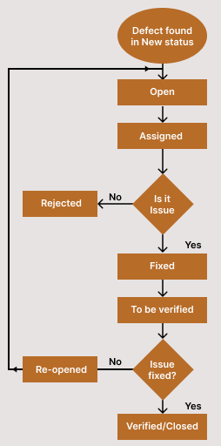

**Phases in defect Management:**

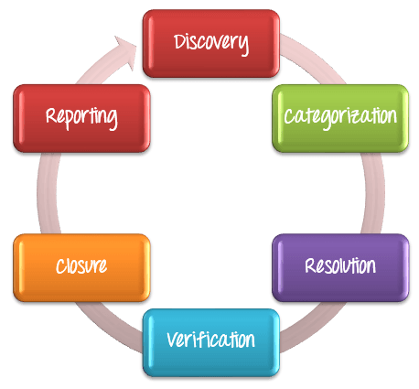

A defect management cycle contains the following stages

**1) Discovery of Defect:**

During the discovery stage, it is crucial for project teams to identify and address as many defects as they can before the end customer experiences them. Defects are considered discovered and move to an "accepted" status once they are recognized and approved by the developers.

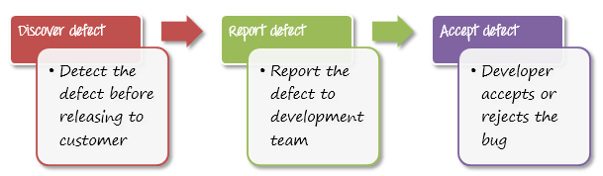

**2) Defect Categorization:**

The process of categorizing defects assists software developers in prioritizing their tasks. This prioritization ensures that overly critical defects are addressed first.

|  |  |
| --- | --- |
| Critical | The defects that must be fixed immediately because it may cause great damage to the product |
| High | The defects that impact the product’s major features |
| Medium | The defects which cause minimal deviation from product requirement |
| Low | The defects which have very minor effect on product operation |

**3) Fixing of Defect by developers**

In software testing, the process of addressing defects is a systematic approach that involves several steps. Initially, defects are assigned to developers who then prioritize them and schedule their resolution accordingly. Subsequently, the defects are resolved, and the developers provide a report of the resolution to the test manager. This process simplifies the tracking and resolution of defects.

Steps to fix defects are as follows:

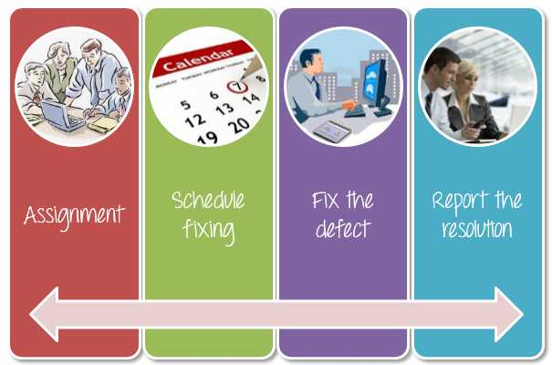

|  |  |
| --- | --- |
| Assignment | The defect is designated to a developer or technician for rectification and its status is updated to "Responding." |
| Schedule Fixing | The responsibility falls on the developers to act. They will establish a timeline for resolving these defects based on their priority level. |
| Fix the defect | While the development team is addressing the defects, the Test Manager oversees the progress of defect resolution in accordance with the established schedule. |
| Report the resolution | Once the defects are resolved, obtain a report of the resolution from the developers. |

**4) Verification by Testers**

The testing team confirms that the flaws are truly rectified after the development team fixed and reported the problem.

**5) Defect Closure:**

A defect is converted to closed status after it has been fixed and validated. If not, you must notify the development team to recheck the fault.

**6) Defect Reports at the end of project:**

Defect Reporting involves Test Managers creating and submitting a report on defects to the management team. This report is used to provide feedback on the status of defects and the defect management process. The management team reviews the report and provides feedback or additional assistance, as necessary. Defect Reporting facilitates effective communication, tracking, and detailed explanation of defects.

**Important defect metrics:**

To evaluate the quality of test case execution, certain metrics can be useful, such as the Defect Rejection Ratio (DRR) and Defect Leakage Ratio (DLR).

DRR is calculated as (Number of defects rejected/Total number of defects identified) *100

DLR is calculated as (Number of defects missed/Total number of defects identified) *100.

A low value of DRR and DLR (around 5~10%) indicates higher quality in the test execution.

## Test Schedule

List the major testing milestones…

|  |  |  |
| --- | --- | --- |
| **DELIVERABLE** | **START DATE** | **END DATE** |
| Design and Functional requirements review | May 1,2023 | June 2, 2023 |
| User story reviews | September 12, 2023 | September 19. 2023 |
| Sprint 1 to Sprint 5 | October 10, 2023, Two-week sprints | February 28, 2023 |
| Test Plan Review | October 10, 2023 | - |
| Test case review, before each sprint | October 10, 2023 | October 30, 2023 |
| Performance and load testing | January 15, 2023 | February 28, 2023 |
| Pilot Release | April 1, 2024 | - |
| Full Deployment | May 1, 2024 | - |
| Project Retrospective | June 1, 2024 | - |

## References

<https://www.lambdatest.com/learning-hub/defect-management>

<https://www.guru99.com/defect-management-process.html>

<https://www.tutorialspoint.com/stlc/stlc_entry_exit_criteria.htm>

## Standards, Plans, and Procedures

|  |  |
| --- | --- |
| **Reference Document** | **Location** |
| Business Requirement and Functional Requirement | [BRD and FSD](https://northeastern-my.sharepoint.com/:x:/g/personal/zope_m_northeastern_edu/ES7SmNiXuFJIs4u2aXsj3uUBg0fDX2CNQkHLZTpXhiIoxw?e=iTAnWJ) |